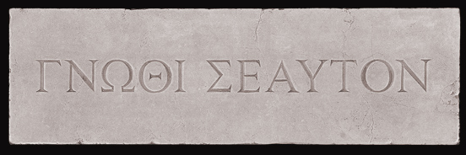
The Oracle of Delphi proclaimed that there was non-wiser than Socrates. But like the inscription above her door, gnothi seauton, Socrates knew himself. He knew what he didn’t know and couldn’t believe that he could possibly be the wisest for he possessed no wisdom. So he set out to question everyone only to find sloppy thinking and intellectual bluster. Only to prove the Oracle correct. He was the wisest in all the land, because he knew what he didn’t know. Socratic Seminars take their name from Socrates, it is up to you to live up to this spirit.
Socratic Seminar
Topic:

After completing your initial research/reading, what is your current position on the topic:

Give AT LEAST three pieces of textual evidence that support your claim

Discussion Questions: Good questions are open ended and help participants examine and revise their own viewpoints.
Remember to stay on TRACK  Test assumptions and explore inferences.  Refer to the text and other relevant sources.  Acknowledge changes in your perspective.  Clarify confusing statements and stay curious  Know what you don’t know and seek to fill in the gaps | On the back of this sheet discuss your position after taking part in this seminar. Use at least five pieces of textual evidence to support your claim.

