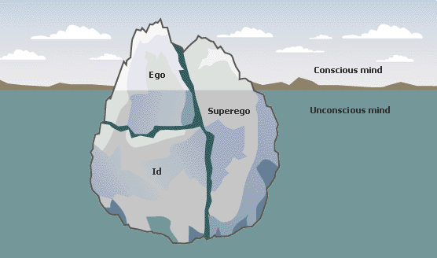Freud’s Theory of Personality

How is this theory like an energy system?

Superego

Id

Ego