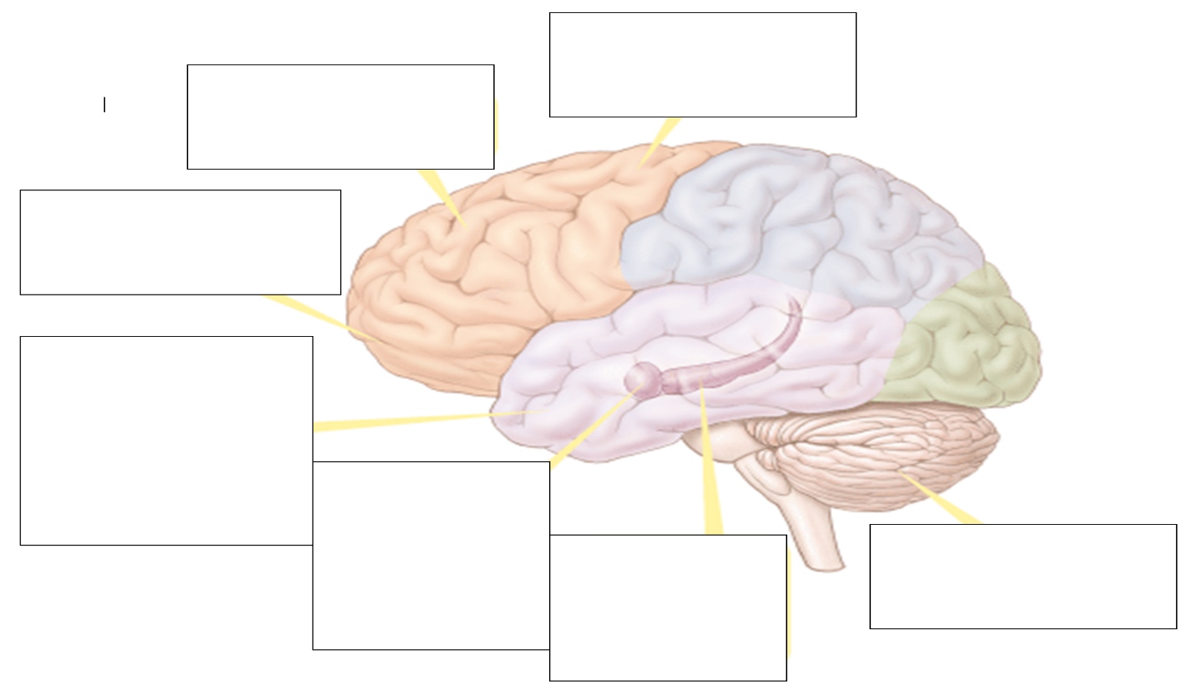
ET 2-3 Describe the physiological systems of memory with specific attention to long-term potentiation and the brain regions where memories are stored.
Key
= VT = Ex
= VP
Biology of memory
Process of memory formation
Long Term Potentiation
Where are memories stored?
Explicit Memory System
Implicit Memory System
Stress Hormones
Systems

