ET 2-1: Describe the information processing model of memory with specific attention to the following steps:
- Encoding: external stimuli, sensory registers, selective attention, reticular formation, short-term memory
- Storage: long-term memory, explicit memory (semantic and episodic memories) and implicit memories (emotional and procedural memories)
- Retrieval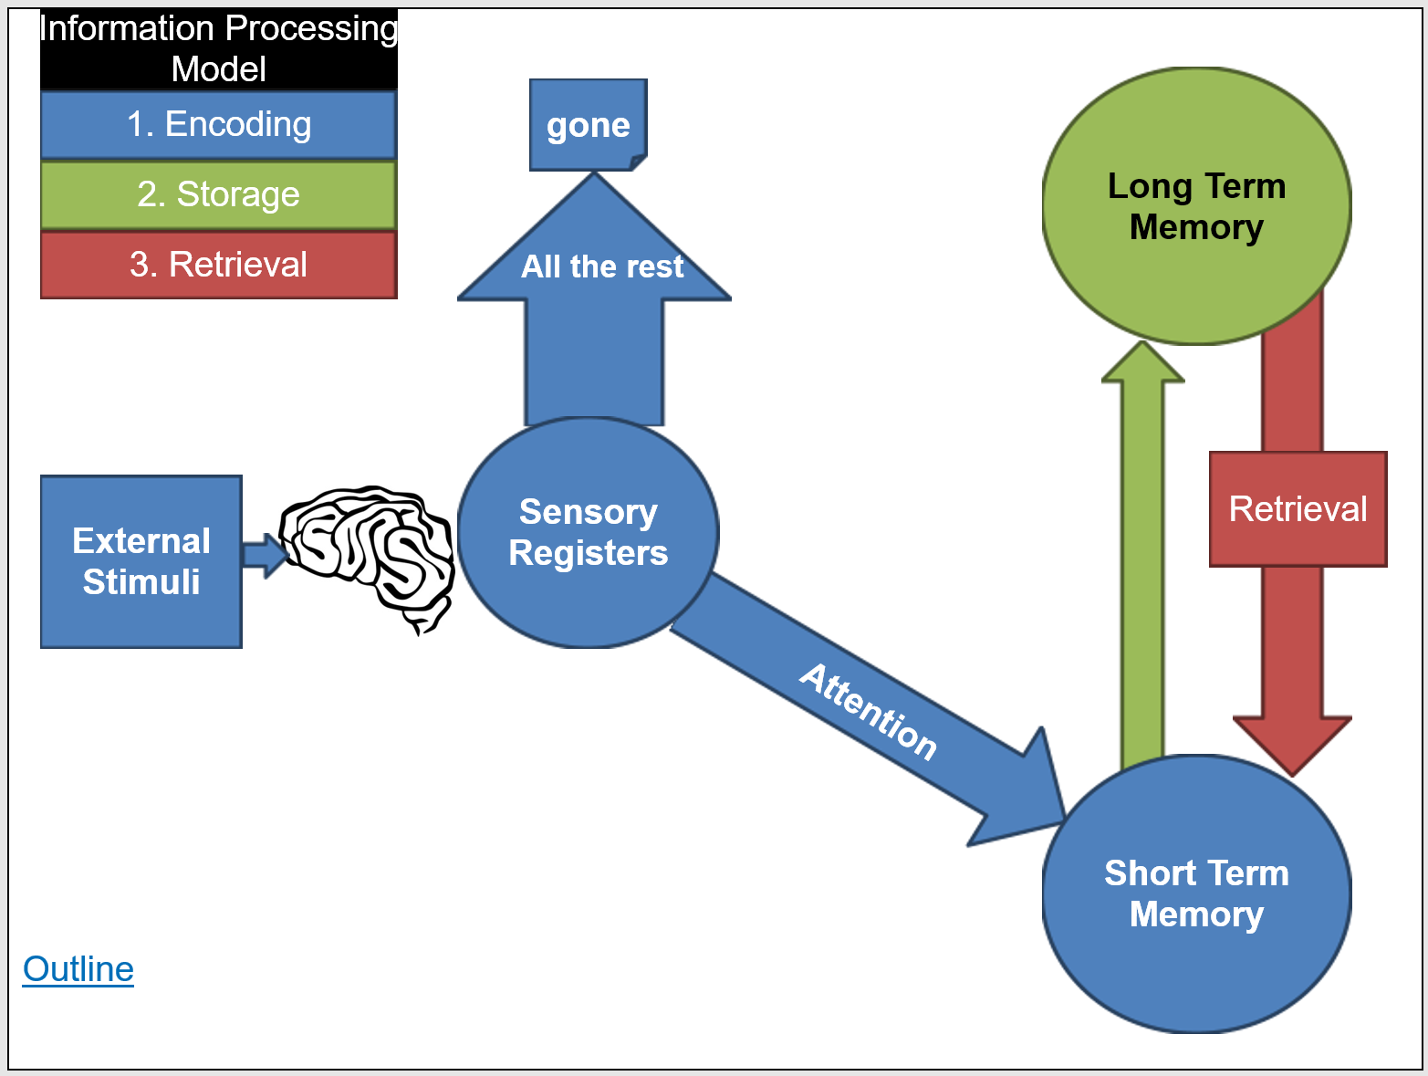
Encoding
Key
= VT = Ex
= VP
Memory
Effortful Processing
Automatic Processing
Parallel Processing
Storage
Retrieval

