Essential Task 1-7: Identify the effects of stress on psychological/physical well-being and how to cope with stress
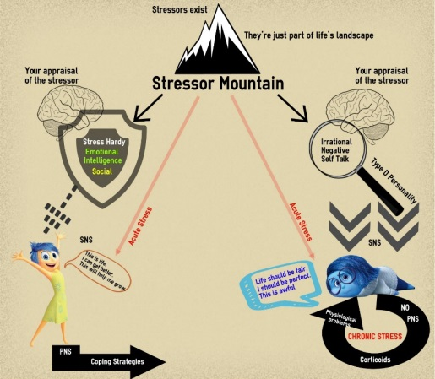
Harmful Appraisal
Stress Hardy

Indirect Coping
Direct Coping
Coping strategies
Health Problems

