Essential Task 1-6: Discuss sources of stress (conflicts, frustration, etc.), measures of stress, and theories of stress (general adaptation theory)
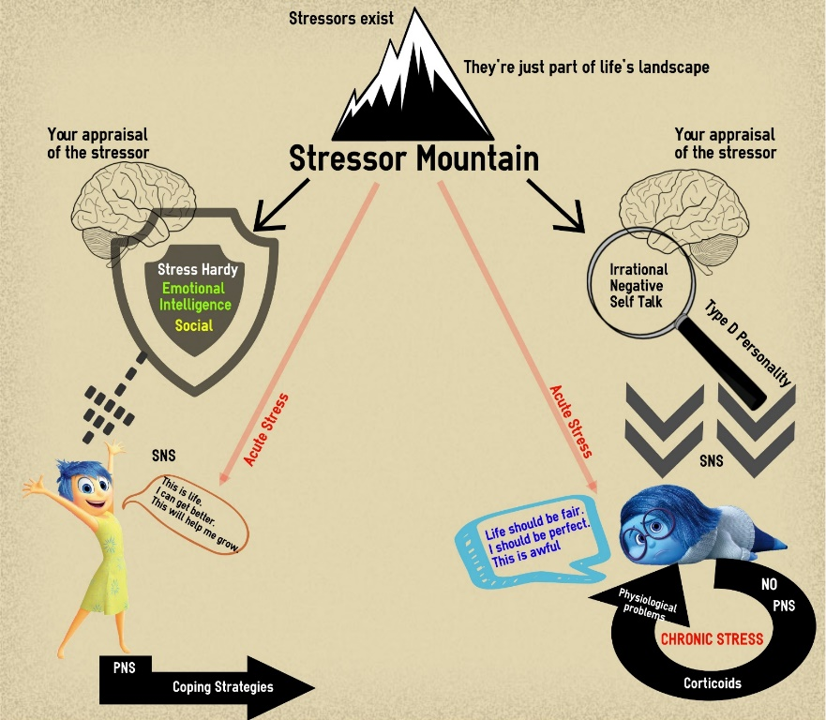
What is the real definition of stress?

Measures of Stress
SRRS

CUSS

Step 1 Stressors
Step 2 Appraisal
Step 3 Stress
Key
= VT = Ex
= VP
Evolutionary

Ex

GAS

Ex

Theories of stress
Chronic Stress

Ex

Acute Stress

Ex

