What’s happening in Europe?
Second Industrial Revolution¹ has just begun.
Italy and Germany² aren’t united yet.
Imperialism³ is just about to start.
WWI⁴ is 54 years in the future.
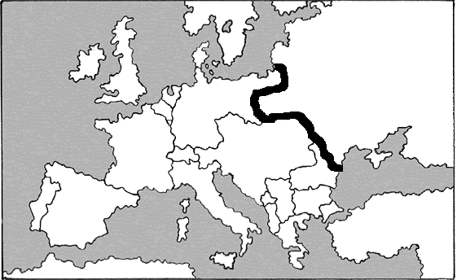

EUROPE

RUSSIA

Europe
- Population:
  - Britain: 20.8 million⁵
  - Germany: 34 million
  - France: 35.8 million⁶
- Percentage of people who can’t read
  - Germany less than 30%
  - Britain about 30-33%⁸

- Percentage of the world’s Industrial Output
  - German: 13.2%
  - Britain: 31.8%¹⁰
- Miles of Railroad lines
  - Franc: 5,696¹²
  - Germany: 6,890
  - Britain: 9,074¹³

- Government
  - Most men¹⁵ have the right to vote¹⁶ in Europe by 1860
  - Democracy¹⁷

Russia
- Population:
  - 68.5 million⁷

- Percentage of people who can’t read
  - 90-95%⁹

- Percentage of the world’s Industrial Output
  - 3.7%¹¹

- Miles of Railroad lines
  - 1,010¹⁴

- Government
  - A king (Russian name is Czar) rules with ABSOLUTE power.¹⁷
  - NO Democracy¹⁸
c. Feudalism – Peasants/farmers are slaves to the land¹⁹
In 1860 Russia is FAR²⁰
behind the rest of Europe
economically, politically and socially.²¹

