5.1 Introduction to Memory
A. Compare and contrast various cognitive processes.
B. Describe and differentiate psychological and physiological systems of memory.
C. Identify the contributions of key researchers in cognitive psychology.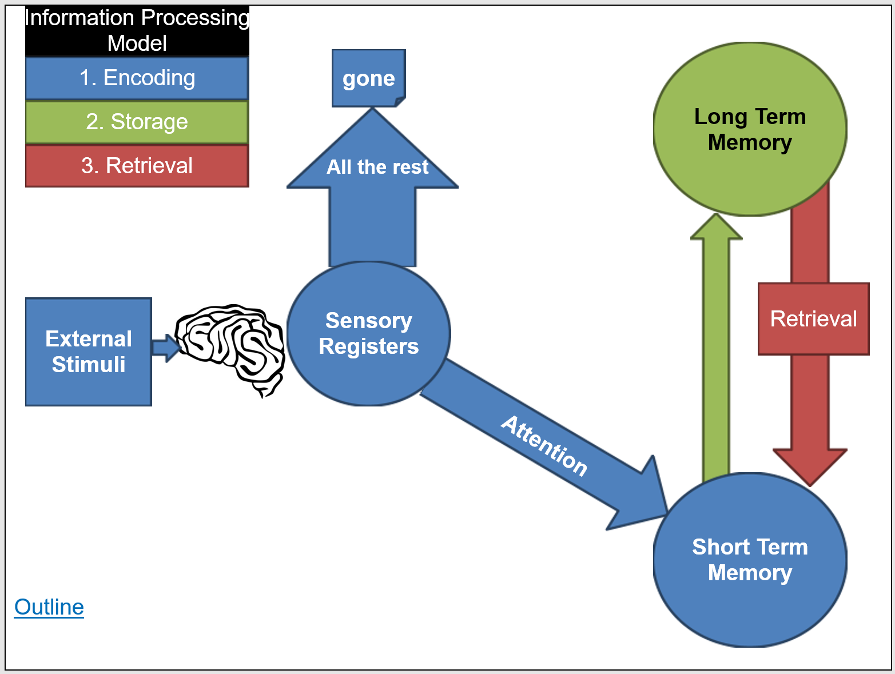
Encoding
Memory
Deep vs. Shallow Processing
Effortful vs. Automatic Processing
Parallel Processing
Storage
Retrieval
Selective vs. Divided Attention

