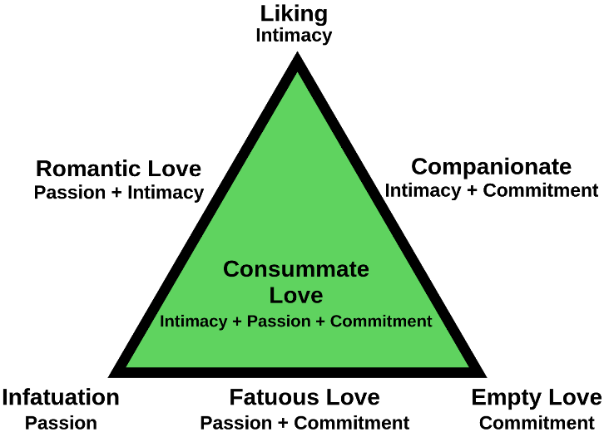

9.7 Interpersonal Attraction  
L. Describe the variables that contribute to attraction.

Attraction

Proximity

Mere Exposure Effect

Attractiveness

Halo Effect

Similarity

**Sternberg's triangular theory of love**