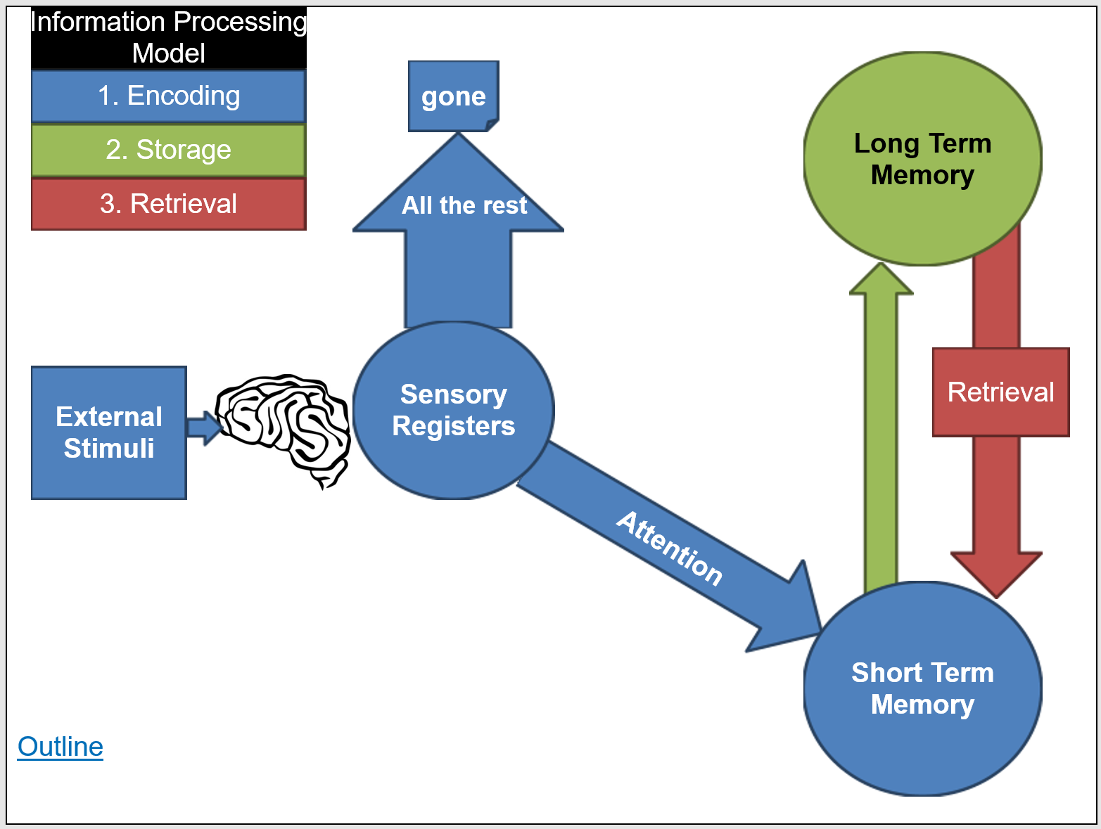**5.2 Encoding**  
D. Outline the principles that underlie construction and encoding of memories. \

Sensory Memory

Iconic Memory Memory

Echoic Memory Memory



Short Term Memory

Rote Rehearsal

